**SHWOZ**



Railway Train System Simulation

User Interface User Manual

Your Name Here

Date

1. **Train Selection**

The Train Controller UI is generic and can be implemented to any train in the system. Each Train will have its own properties. One should choose the train they wish to operate by clicking the Train Selection Button shown in figure 1. After the correct train is chosen, user can operate through the Train Controller.



Figure 1: Train Selection button

1. **Attributes Overview**

All the attributes related to the chosen train will be displayed in the Attributes Overview Window, including Current Speed, Current Authority, Current Acceleration, Light Status, Door Status, Current Speed Limit, Next Station name, air condition (temperature in the train cart) and Route Information. The Attributes Overview is shown in Figure 1.

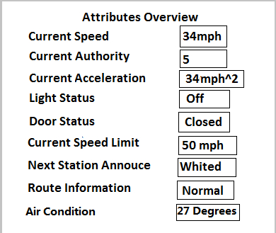

Figure 1: Train Controller Attributes Overview Window

All the attributes are real-time feedback from the train. Therefore the status will vary as train moves along the track.

1. **Control Panel**

Certain attributes of the train can be controlled through Control Panel, which is shown in figure 2.

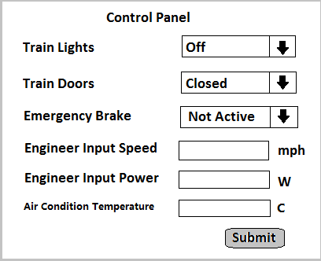

Figure 2: Train Controller Control Panel Window

To manually change the train light status, the Train Light button should be chosen and change the status to change the light status. To manually open the door, the Door button should be chosen and change to the status to change the door status. Also, engineers have the ability to manually input the speed and power through the panel those 2 options accept float numbers. The air conditioner can also be controlled through the control panel. The temperature shall be float numbers. To hit the emergency brake to stop the train under special situation, the Emergency Brake Button should be clicked.

After the desired modification is chosen, click the ‘Submit’ button on the button right to apply the changes.

1. **Input/Output signals**

The Train Controller will receive suggested signal from train, including suggested speed, authority, acceleration, and by calculating the parameters with the train’s own properties, and the distance from the destination, the Train Controller will output the final speed, authority and acceleration to the Train. It will prevent train from going over its acceleration or authority from invalid inputs. The window is shown in figure 3.

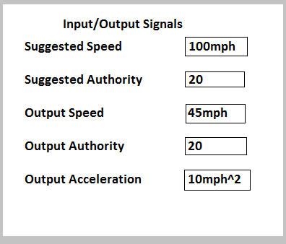

Figure 3: Train Controller Input/Output Signals Window

1. **Failure Detection**

A log is kept to report the failure parts of the train, which is shown in Figure 4.

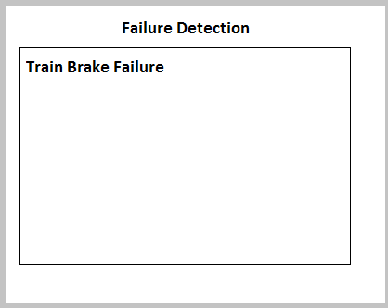

Figure 4: Train Controller Failure Detection Window

As denoted in Figure 4, the name of the failure parts will be shown.